 

ASSIGNMENT ON INTERNET TECHNOLOGY(IT)

Assignment Weightage & Type

60% Portfolio Coursework

Corse: BSc (Hons) CS & DF (Sem_2)

**NAME: AMAN YADAV**

**STUDENT ID: 10722**

**WEEK 6**

**EXERCISE-1**

Design a web page using four different image files ‘image1.jpg’, ‘image2.jpg’, ‘image3.jpg’ and ‘image4.png’ according to the following specifications.

• Use a border 5px for ‘image1.jpg’.

• Resize the width and height of ‘image2.jpg’ 100 pixels each. Use anchor tag on

this image and open original image.

• Align ‘image3.jpg” to either left or right side

• Leave space of 50px horizontally and vertically in ‘image4.png’

• align the text with respect to the images so as to obtain the appropriate output.

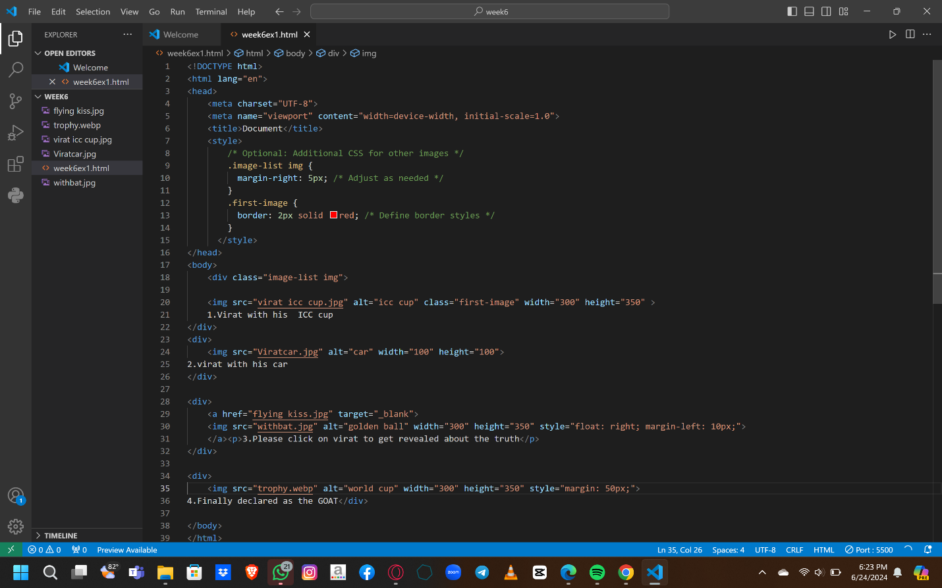

OUTPUT:-

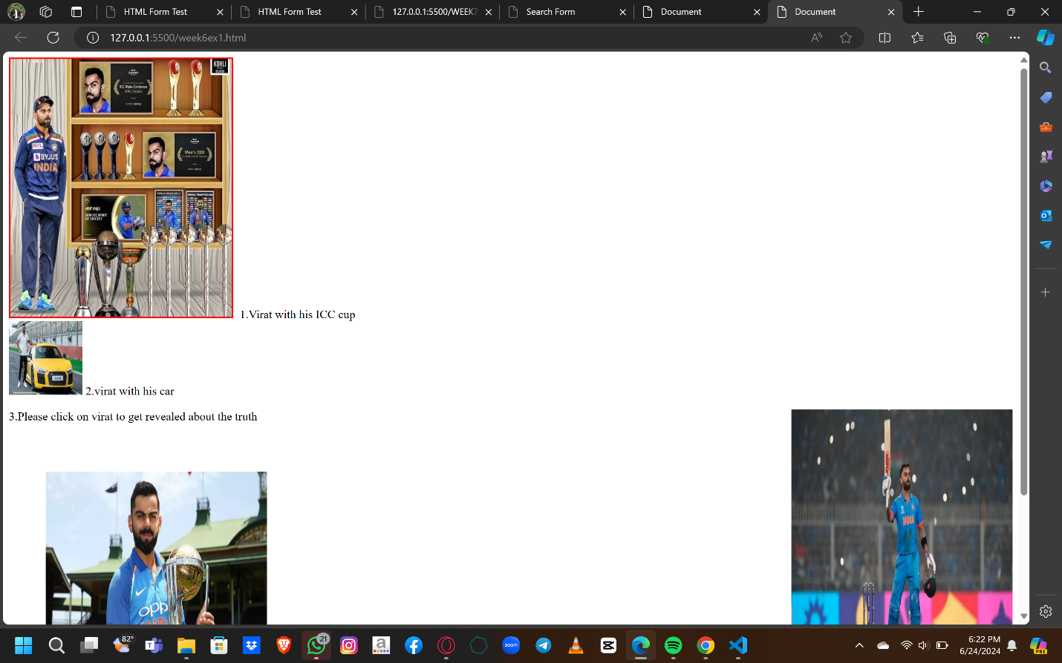

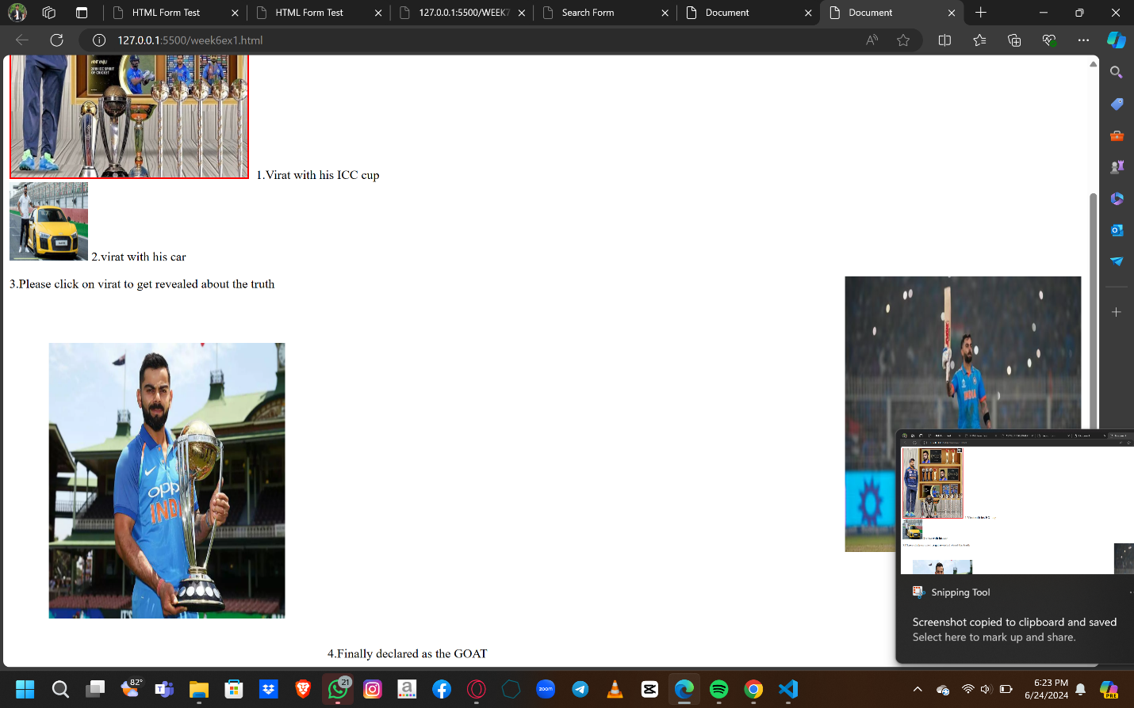

EXERCISE -2

Create a document home.html with two links to an external document (about.html). The first link should lead to the beginning of the about.html. The second link should lead to a particular section Contact information in the about.html. Home.html should also contain a google logo of size 400px X 100px. On clicking this image, it should redirect to [www.google.com](http://www.google.com) [Note: Make your own design and content]

OUTPUT:

HOMEPAGE:

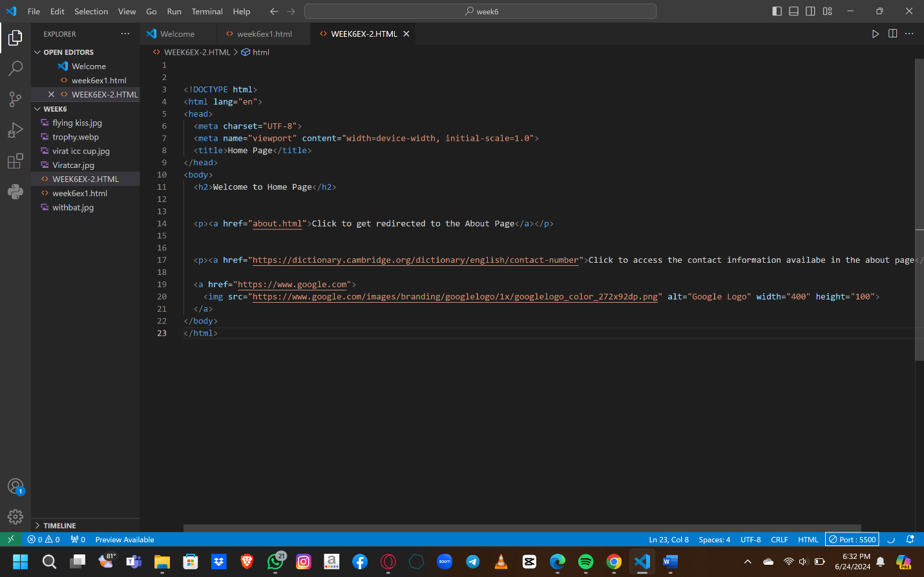

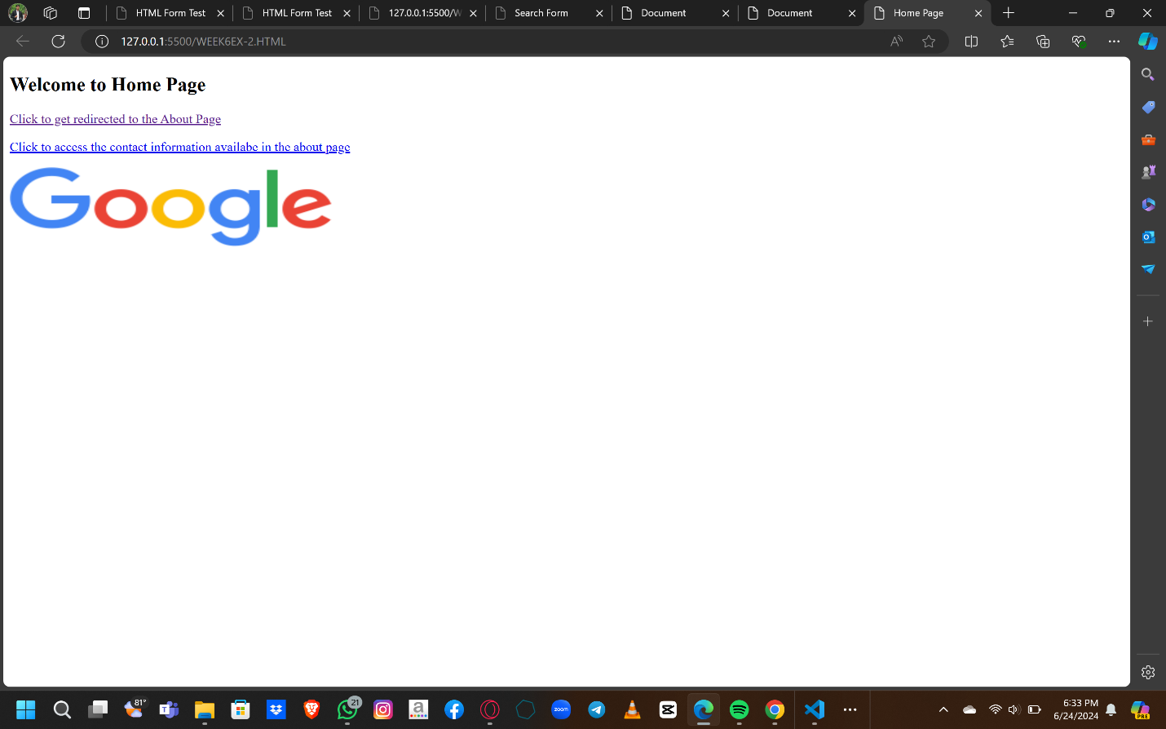

ABOUT PAGE:

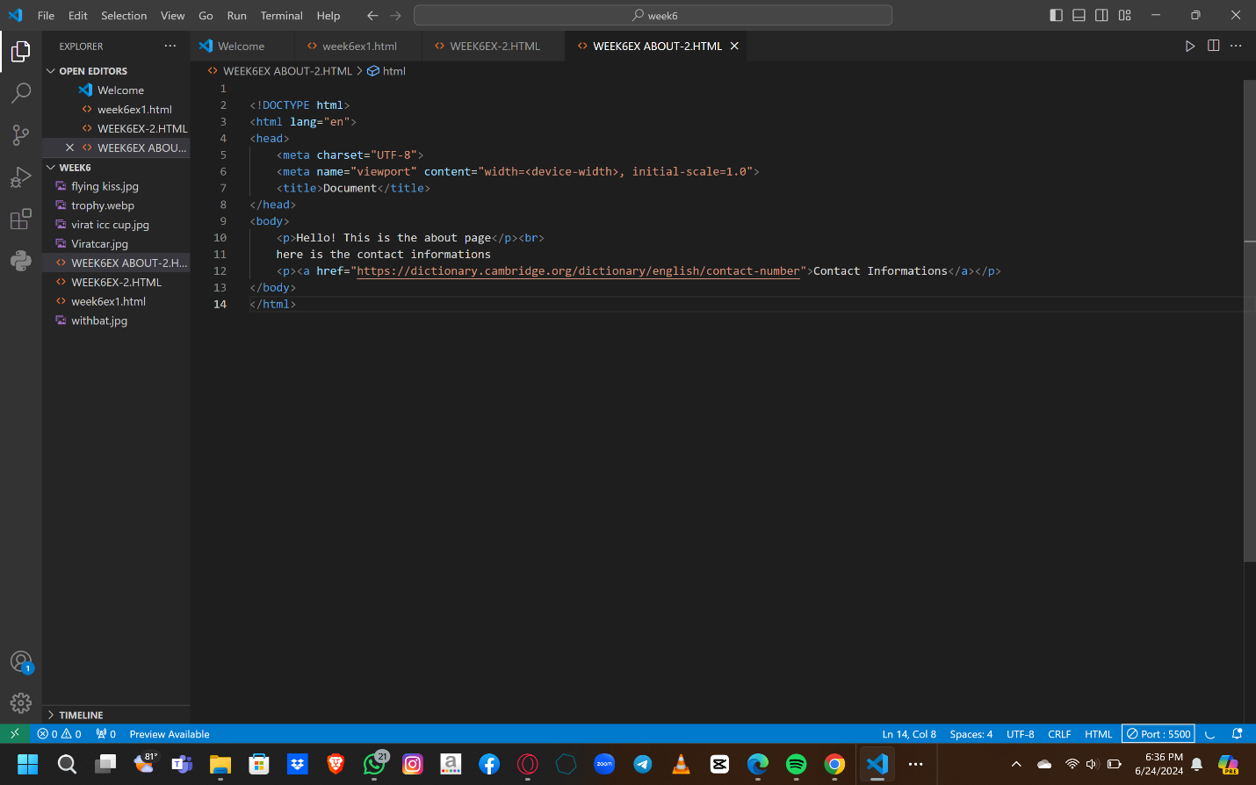

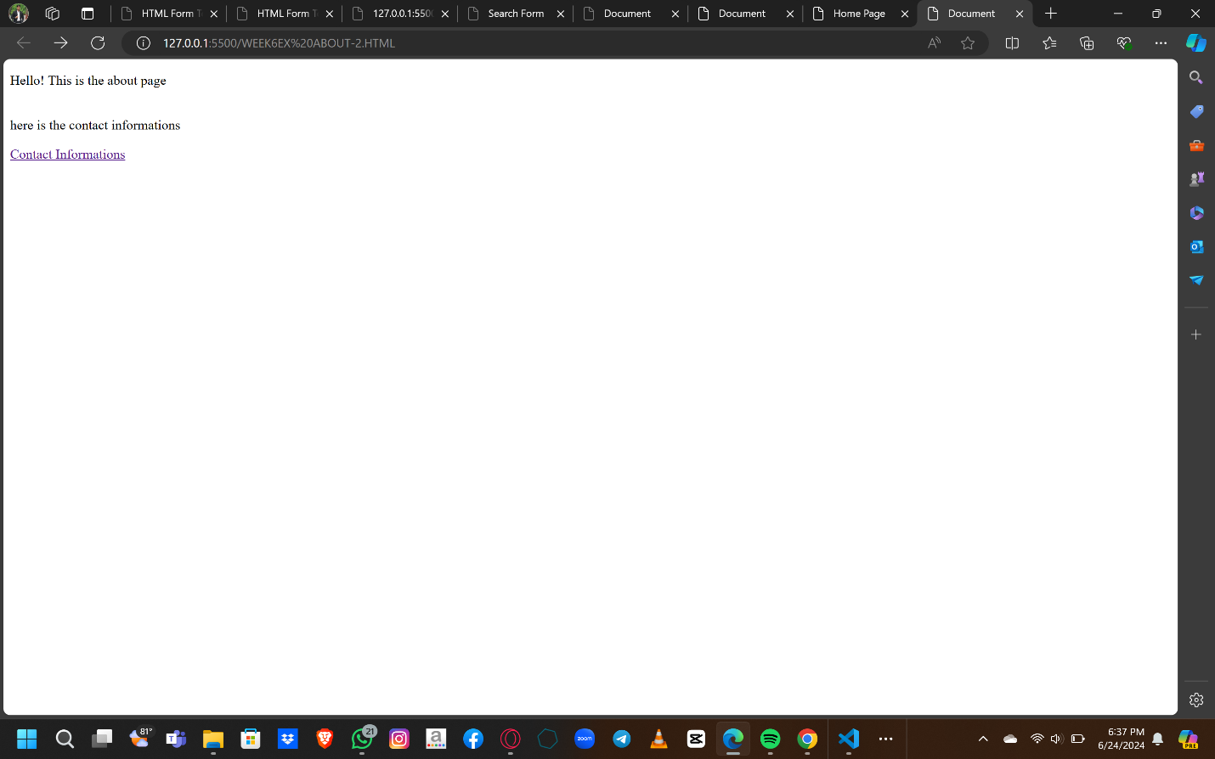

EXERCISE - 3

Create a Web page giving the following Bus details. Place a border for the table and use cell padding to present the cell data with clarity. Align the table in the center of the screen. Use a caption saying ‘Bus Sewa Time Table and Fare List’.